Week 13 Lab Exercise – Git & GitHub

Name: ________________________________________ Date: __________________ Set: _____

# Part 1: Installing Git and creating local repository

In this lab exercise, you will install the version control software called Git and create a local repository.

* Point your browser to the msysGIT project at [http://msysgit.github.com](http://msysgit.github.com/).
* Click on *downloads* link on the right-hand-side
* Download the latest .exe file

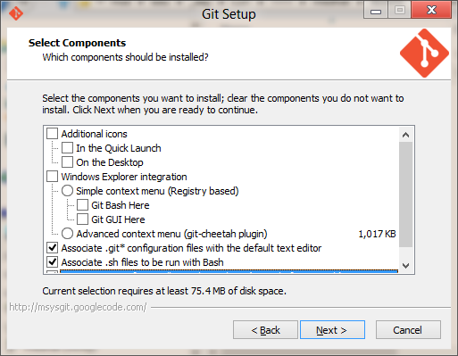  
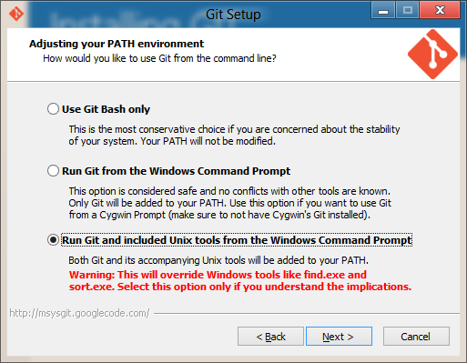

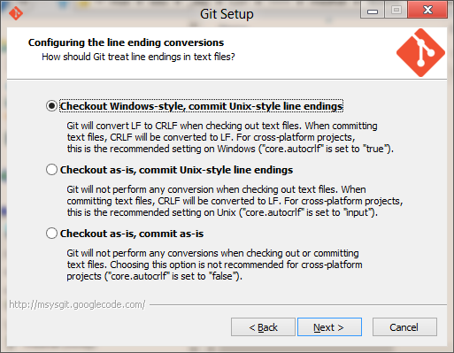

* Start PowerShell
* Create a directory for your repository named “GitStar”: *mkdir GitStar*
* Go to that directory: *cd GitStar*
* Initialize repository: *git init*
* Set your Git user name and e-mail address:

*git config --global user.name "<your name>"*

*git config --global user.email "<your email>"*

Example:

*git config --global user.name "Bob Roy"*

*git config --global user.email "bob.roy@coldmail.com"*

* Verify that your name and email address are set properly in Git:

*git config --global --list*

* Create a file named *Foo.txt* in the *GitStar* directory and add your *Name* into its content.
* Enter the following in the *PowerShell* window: *git status*
* You will see a file in red indicating that it is not being tracked.
* Add file to the Git repo with: *git add .\Foo.txt*
* To commit *Foo.txt* to the repo, enter: *git commit -m "Added a new file"*
* Edit *Foo.txt* by adding your student number into it. Then add and commit changes with:

*git add -u*

*git commit -m "Added student number to Foo.txt"*

* You can see the history of commits by typing the command: *git log*. You will see two transactions.

<<< Place screenshot of PowerShell window here showing output of *git log* command. >>>

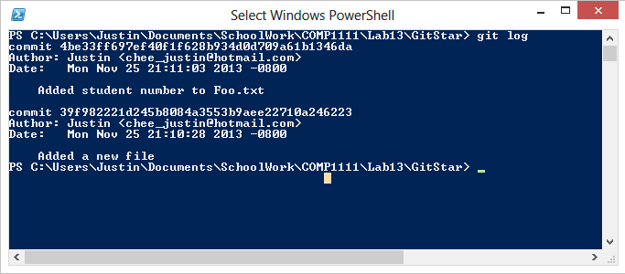

# Part 2: Subscribe to GitHub and participate in group project

The objective in this exercise is to have the entire set participating in group project involving the development of a website that contains information about your COMP1111 lab set in this current term. The website will look like this:

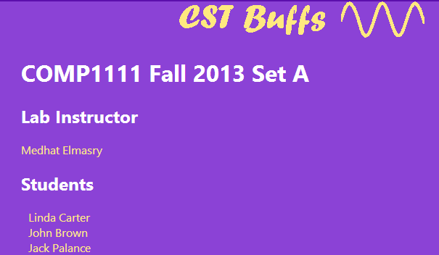

Each student will add the following artifacts:

Note: The colors of these pages differs by set.

MedhatElmasry.html

LindaCarter.html

Index.html

* Copy *LindaCarter.html* to another *html* file named with your name: *FirstnameLastname.html*. Do not rename *LindaCarter.html* to become your name.
* Edit the file with your name file and repurpose it with your picture and your information.

**Code of conduct**

You should not include any content and/or images that are disrespectful to others. It is, however, suggested that you put a real photo and real information about yourself.

Refrain from putting your real email address so you do not get spammed.

* Edit the already existing *index.html* file by adding a link to your bio page.

If you have not done so already, subscribe to [http://GitHub.com](http://GitHub.com/). After you join GitHub, you will clone the appropriate remote repository for your set:

|  |  |  |  |
| --- | --- | --- | --- |
| **Set** | **Clone URL** | **Project name** | **Color Theme** |
| A | https://github.com/medhatelmasry/awassa.git | **a**wassa | purple |
| B | https://github.com/medhatelmasry/benin.git | **b**enin | green |
| C | https://github.com/medhatelmasry/chad.git | **c**had | blue |
| D | https://github.com/medhatelmasry/dude.git | **d**ude | reds |
| E | https://github.com/medhatelmasry/eden.git | **e**den | yellow |

* On your computer, in PowerShell, go to the *parent* *directory* of *GitStar*.
* Clone your repository by typing the command:

*git clone <your set’s clone url from the above table>*

* A directory will be created in the project name
* Install WebMatrix if you do not have it on your computer already
* Right-click on the project name directory and select “Open as Web Site with Microsoft WebMatrix”
* Run *index.html* in a browser and get a feel for the current state of the application
* Make the necessary changes as described at the beginning of this Part 2 exercise.
* After you are done making your changes:

*Source Control >> Commit*

Enter a *message* describing the changes you made then click *OK*

* To push the changes to GitHub :

*Source Control >> Push >> origin*

* There will be many students in your set working on the project at the same time. You should make frequent pulls to view changes to the application that others have done.
* Also, it is a good area to make frequent commits and pushes whenever you add, delete, or edit a document.

This is what solution explorer looks like (with all the folders expanded) before you made any changes: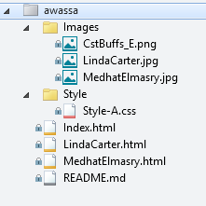

<<< Place screenshot of your WebMatrix solution explorer after you made changes, committed and pushed to GitHub >>>

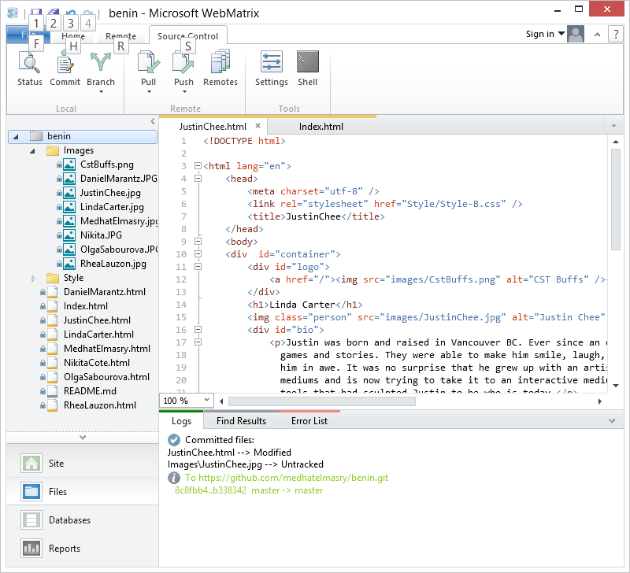

# Part 3:

The third part is a challenge that you must accomplish on your own by reading the notes I have given you.

1. Return to the *GitStar* repository that you created in part 1.
2. Copy into it your favorite Java lab or assignment from COMP1510.
3. In the *GitStar* directory create a text file named *.gitignore*. Edit this text file and insert into it \**.class,* so that compiled java classes get ignored by Git.
4. Commit and push your local repository into GitHub.

<<< Place browser screenshot of repository on http://github.com with pushed source code java files, excluding .class files >>>

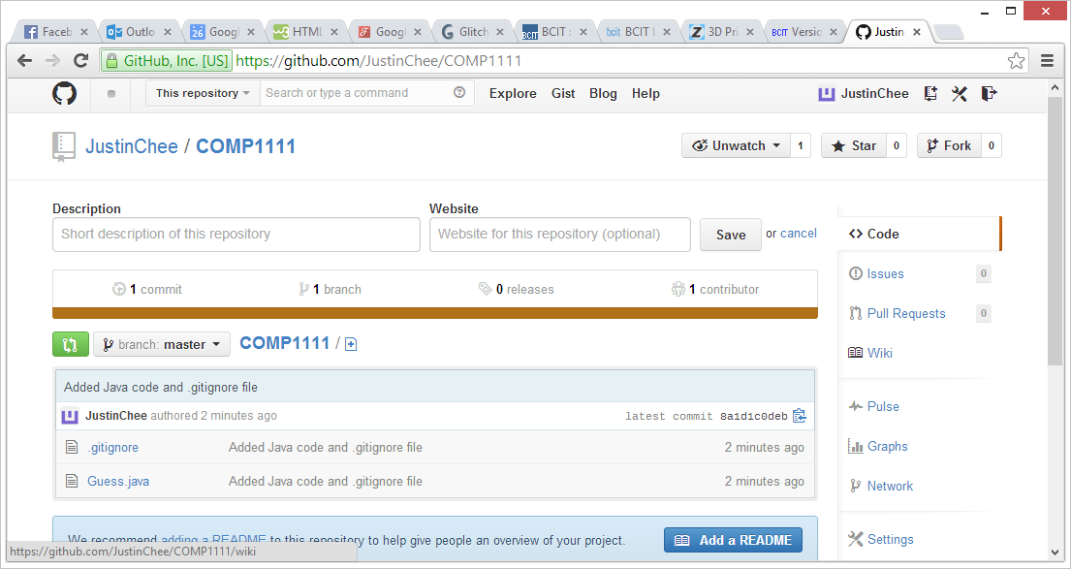

## Evaluation (Marking guide)

* When you are done, show your work to your lab instructor.
* Hand in your completed word document, in *docx* format, to
* *Share/In/COMP/1111/Labs/Week-13*. Your submission will be graded out of 10 marks.
* If you do not complete this lab exercise in the lab you will lose 1 mark for late submission. You have until midnight on the same day to submit your work.

|  |  |  |
| --- | --- | --- |
| Marking Guide | | Mark |
| Part 1 | Screenshot of PowerShell window showing output of git log command showing local repository transactions | 2 |
| Part 2 | Screenshot of your WebMatrix solution explorer after you made the changes to group project and pushed them to GitHub | 3 |
| Part 3 | Challenge involving pushing local GitStar repo to GitHub. The GitStar contains a Java project | 5 |
| TOTAL | | 10 |